The Image tools interface can be open by calling the “Image_tools” script in the Matlab command line:



This script calls the main user interface for the toolbox, which offers functionality for display and camera characterization, image calibration, and several other utilities. The available options are (Fig. 1):

* Camera characterization
* Display characterization
* Image calibration
* Image calibration (batch mode)

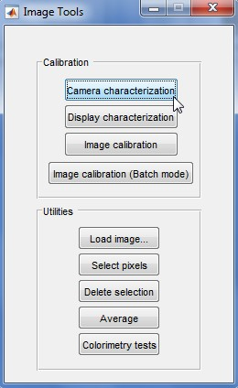

Camera characterization:

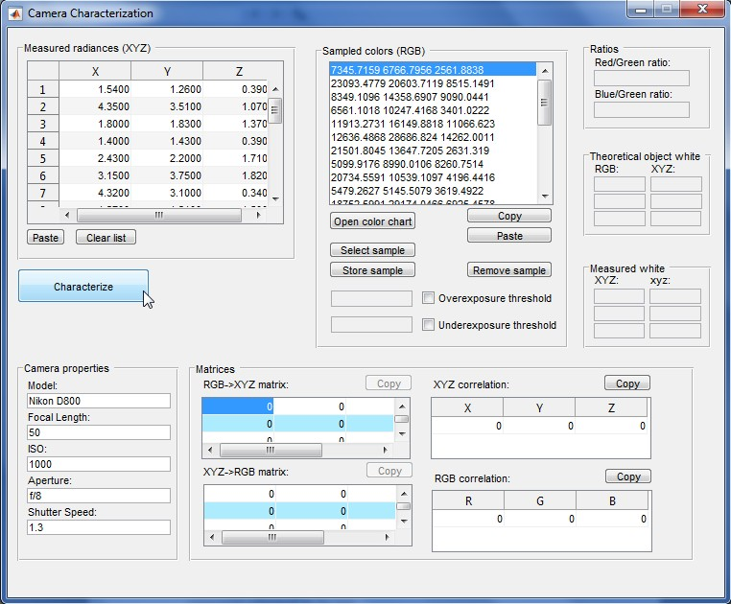

4

6

2.1

2.2

2.3.

5

2

3

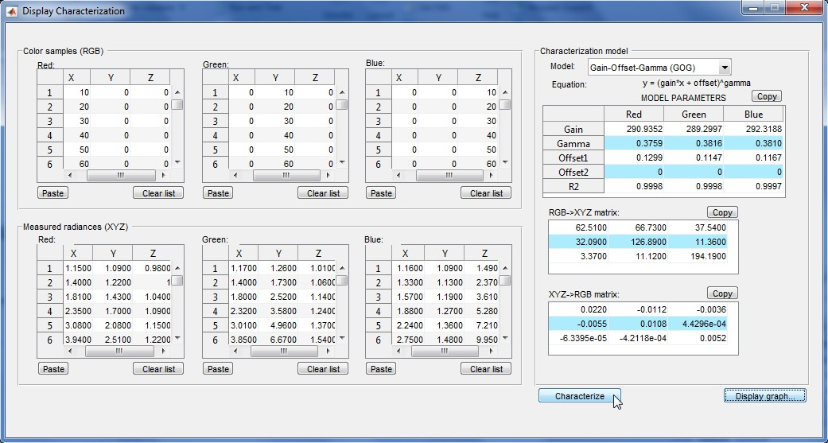

2.2

2

1

3

4

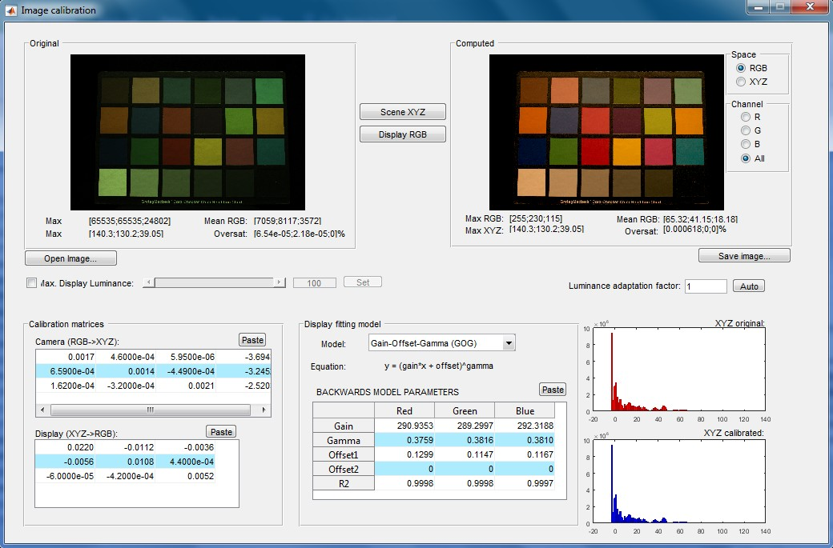

3

4

2.2

2.1

1